- Одреди непознат број:
- На основу података са слике одреди непознате величине.
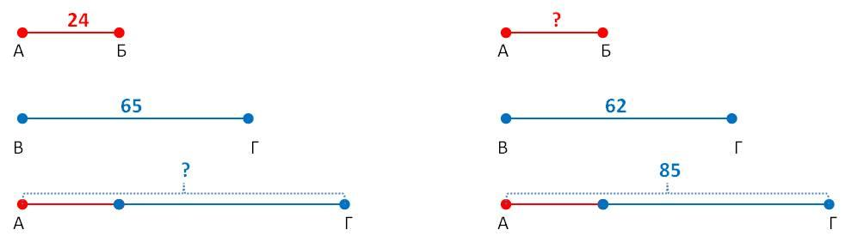

3. Попуни таблицу:
а | 61 |  | 33 | 45 | 4 | 46
б |  | 2 |  | 8 |  | 15
а + б | 87 | 59 | 23 |  | 58

- Ђорђе је имао 65 сличица. Од брата је добио још неколико, тако да је после тога имао 82 сличице. Колико је сличица добио од брата?

- Змислио сам неки број. Када сам му додао број 14 добио сам број 60. Кoји број сам замислио?

Х + 13 = 60;
ј е д н а ч и н е
--------------------------------------
--------------------------------------
--------------------------------------
х – 18 = 31;
----------------------------------------
----------------------------------------
----------------------------------------
50 – х = 22;
-----------------------------------------
-----------------------------------------
-----------------------------------------
67 + х = 100
------------------------------------------
----------------------------------------
-----------------------------------------

